**scores (main class)**

/* Define array and output sorted array from sorter class

Chris Mayfield (G00048645)

*/

package scores;

public class scores {

public static void main(String[] args) {

// declare, instantiate, and assign array values

double [] dArr = {53.5, 60.3, 96.2, 53.3, 56.4, 52.7, 76.4, 77.5, 71.0,

78.2, 65.2, 59.3, 80.5, 92.1, 85.7, 78.7, 66.2, 88.8, 50.2, 73.4};

// create a new sorter object s1

dSorter s1 = new dSorter();

s1.selectionSort(dArr);

// output to console

for(int i = 0; i < dArr.length; i++)

System.out.println(dArr[i]);

}

}

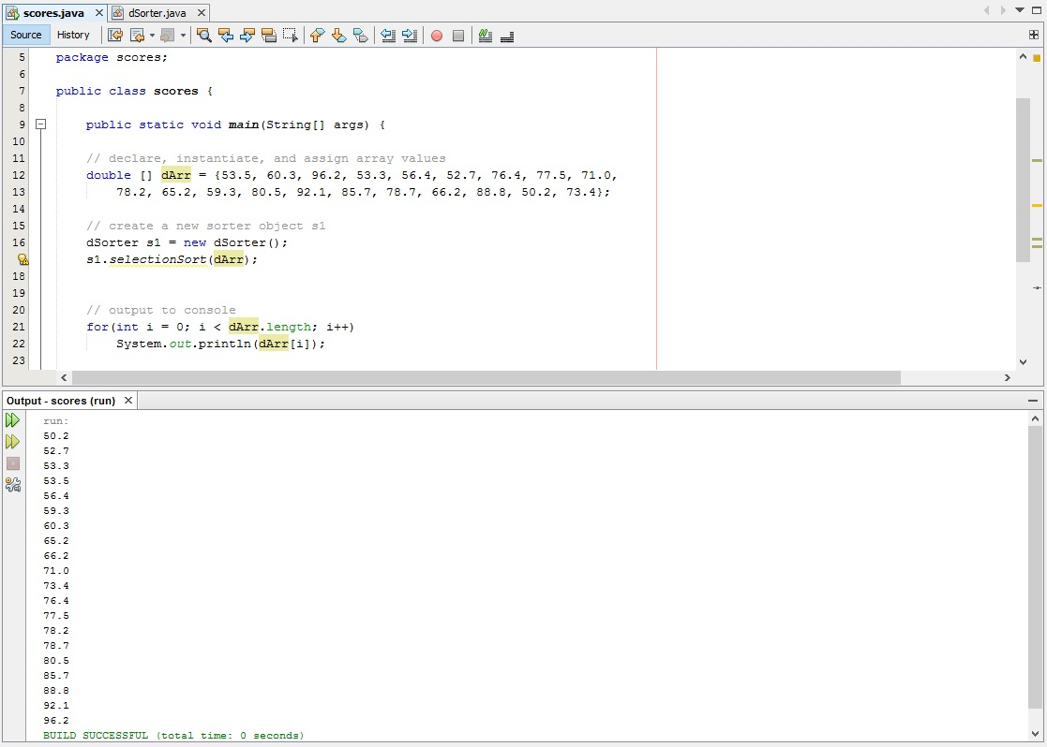

**dSorter (selection sort class)**

/* selection sort class for double array

Chris Mayfield (G00048645)

*/

package scores;

public class dSorter {

public static void selectionSort (double [] dArr){

// initialize variables

int i = 0, j = 0, max = 0; // variables must be int for loop function

double temp = 0.0; // temporary location for swap must be double

// loop for sorting

for (i = 0; i < dArr.length - 1; i++)

{

// find index of largest value in subarray

max = indexOfLargestElement( dArr, dArr.length - i );

// swap array[max] and array[array.length - 1 - i]

temp = dArr[max];

dArr[max] = dArr[dArr.length - i - 1];

dArr[dArr.length - i - 1] = temp;

}

}

/** Finds index of largest element

* @param dArr the array to search

* @param size the size of the subarray

* @return the index of the largest element in the subarray

*/

private static int indexOfLargestElement(double [] dArr, int size){

int index = 0;

for( int i = 1; i < size; i++ ){

if( dArr[i] > dArr[index] )

index = i;

}

return index;

}

}

